**Inheritance**: Inheritance is passing down behaviours and properties from parent class to child class; classes can inherit characteristics and behaviors from other classes. This makes it easier to create new things that are similar to existing ones.

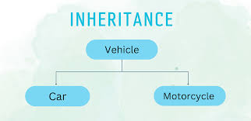

class Animal:

def __init__(self, name):

self.name = name

def sound(self):

return "Some sound"

class Dog(Animal):

def sound(self):

return "Bark"

class TrainedDog(Dog):

def sound(self,command):

if (command == "Speak"):

return "Bark"

else:

return "..."

# Using Inheritance

dog = Dog("Buddy")

print(dog.name)

print(dog.sound()) # Dog inherits the properties and methods of Animal

trainedDog = TrainedDog("Rocky")

print(trainedDog.name)

print(trainedDog.sound("No command"))

print(trainedDog.sound(""))

print(trainedDog.sound("Speak")) # Dog inherits the properties and methods of Animal

**Polymorphism –** Changing behaviours based on context. A derived class object will behave differently in case the behaviour is altered.

list = [dog,trainedDog]

for dogObj in list:

print("Polymorphism - "+ type(dogObj).__name__ + " cries " + dogObj.cry())

**Encapsulation -** It is about keeping the important stuff hidden and share what is necessary. E.g. Access modifiers – public, private, internal etc.

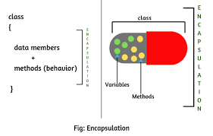

class BankAccount:

def __init__(self, owner, balance=0):

self.owner = owner

self.__balance = balance # Private variable, hidden from outside

def deposit(self, amount):

self.__balance += amount

def withdraw(self, amount):

if amount <= self.__balance:

self.__balance -= amount

else:

print("Insufficient balance.")

def get_balance(self):

return self.__balance

# Creating a bank account

account = BankAccount("Alice")

account.deposit(100)

print(account.get_balance()) # Can only access balance through method

# account.__balance = 500 # This will give an error because __balance is private

**Abstraction** : Hiding complexity – Identifying common things. We use cellphones to talk, play, use apps. We do not care about how it is working. It helps make the code simpler and easier to work with by only exposing the necessary functionality while hiding the complex parts.

class Animal:

def __init__(self, name):

self.name = name

def sound(self):

return "Some sound"